**Impacts of temperature on predator-prey interactions in an African savanna**

D. Rabaiotti1,2, Adam T. Ford3, Ben Chapple2, Sophie Morrill2,

and Rosie Woodroffe1

1Institute of Zoology, Regents Park, London NW1 4RY, UK.

2Department of Genetics, Evolution and Environment, University College London, Gower Street, London, WC1H 0AG

3Departent of Biology, University of British Columbia, 3187 University Way, ASC 413, Kelowna, BC Canada V1V 1V7

**Abstract**

1. Impacts of climate on species often occur indirectly through species interactions. It is therefore important we consider multiple species when looking to predict how climate change will impact wildlife in the future.
2. One of the key ways in which species interactions are impacted by climate change is through shifts individual behaviour. Climatic changes can cause species mismatches between predators and prey, increase flight speeds in prey or attack speeds in predators, and lead to shifts in habitat use, changing spatial overlap between predator and prey species. All of these have implications for predation rate and subsequent population dynamics.
3. Here we examine how high temperatures can impact predator prey dynamics through individual behaviour in a three species system made up of a predator, the African wild dog, *Lycaon pictus*, and two prey species: impala, *Aepyceros melampus* , which have a larger body size than wild dogs, and dikdik, *Madoqua guentheri* , which have a smaller body size than wild dogs.
4. We found a clear association between ambient temperature and the behaviour of predator and prey species. Wild dogs hunted for shorter periods at high temperatures and did not preferentially target impala when temperatures were higher. Despite impala using greater woody cover at high temperatures, increasing the similarity between the woody cover use by wild dogs and impala, fewer wild dog scats contained impala when temperatures had been hotter.
5. Our findings are consistent with optimal foraging theory, whereby predators with limited time should select for abundant, lower value prey over rare high value prey.

**Keywords:** African wild dog;antipredator behaviour; climate change; dikdik; habitat selection; impala; predation; predator

**Introduction**

Climate change has far-reaching impacts on both species and ecosystems (Parmesan & Yohe 2003). Meta-analyses suggest that climate impacts on individual species often operate indirectly, through their effects on species interactions such as competition, herbivory, predation, and parasitism (Cahill *et al.* 2012; Ockendon *et al.* 2014). This observation suggests that understanding how weather affects species interactions may help to make general predictions about which species are most vulnerable to climate change and, hence, in need of conservation action.

The effect of climate on species interactions also has impacts beyond individual species. Global Ecosystem Models, such as the Madingley Model, are designed to predict worldwide ecosystem responses to climate change, with a view to informing policy decisions about activities such as carbon emissions and land use planning (Harfoot *et al.* 2014). Such models are likely to be sensitive to assumptions about how climate influences species interactions, because interactions between species play a central role in shaping ecosystems.

One mechanism whereby climate may influence species interactions is through the impact of weather on individual behaviour. For example, rising ambient temperatures may allow ectotherms to move more rapidly, potentially making them more efficient predators and more challenging prey, with cascading consequences for community structure (Dell, Pawar & Savage 2014). It is usually assumed that temperature has no similar impacts on predation involving endotherms (e.g., Dell, Pawar & Savage 2014; Harfoot *et al.* 2014); however, birds and mammals can respond behaviourally to high ambient temperatures by curtailing their foraging time (Ricklefs & Hainsworth 1968; Quaglietta, Mira & Boitani 2018), switching from diurnal to nocturnal foraging (Levy *et al.* 2018), selecting different habitats (Austin 1976; Pigeon *et al.* 2016), and choosing different foods (Doolan & Macdonald 1996; Garcia-Heras *et al.* 2017), all of which are likely to influence their impacts on the species that they consume, or that consume them. Moreover, it has been suggested that predator-prey interactions involving large-bodied endotherms might be especially sensitive to temperature, because the low surface-to-volume ratios of large animals may make it difficult to dissipate the heat generated by pursuing or avoiding predation (Speakman & Krol 2010; Creel *et al.* 2016). Hence, high ambient temperatures might potentially favour endothermic prey which are smaller than their endothermic predators, and endothermic predators which are smaller than their endothermic prey (Creel *et al.* 2016). Predation by and on large-bodied endotherms can have cascading effects on community structure (e.g., Fortin *et al.* 2005; Johnson, Isaac & Fisher 2007), and these effects might therefore be sensitive to ambient temperature.

These examples shows the multiple ways in which one element of climate change (rising ambient temperature) might alter individual behaviour and hence influence one type of species interaction (predation involving endotherms). We explored the relative importance of these potential mechanisms using a three-species predator/prey system in an African savanna, where two ungulate species, the impala (*Aepyceros melampus*) and dikdik (*Madoqua guentheri*) share a common predator, the African wild dog (*Lycaon pictus*). At our study site in Kenya, impala and dikdiks are the two most abundant mammalian herbivores, and their browsing has measurable impacts on the structure of plant communities (Ford *et al.* 2014; Ford *et al.* 2015). Wild dogs are crepuscular predators which hunt their prey by running them down (Creel & Creel 1995); dikdiks and impala together comprise 82% of the prey biomass that wild dogs consume at our study site (Woodroffe *et al.* 2007). We evaluated four sets of hypotheses about the impacts of ambient temperature on wild dog predation, based on predicted behavioural changes by predator and prey (Table 1).

First, we explored the potential consequences for predation of reduced activity time during daylight, when solar radiation makes ambient temperatures highest. We have shown previously that wild dogs exhibit lower mean daytime activity on hot days (Rabaiotti & Woodroffe 2019), which we have suggested may reflect shorter hunting periods (Woodroffe 2011b). Optimal foraging theory suggests that, when foraging time is restricted, individuals should accept lower-value prey when encountered, rather than continuing to search for higher-value prey (Lucas 1983). In line with this theoretical prediction, we predicted that wild dogs with restricted foraging time would increase predation on dikdiks, which are abundant but too small to feed a whole pack, over impala, which are larger but encountered less frequently (Woodroffe *et al.* 2007).

Second, we explored the potential consequences for predation of increased nocturnal activity. We have shown previously that wild dogs show higher mean night-time activity following hot days, which we have suggested might reflect increased nocturnal hunting (Rabaiotti & Woodroffe 2019). We predicted that this change might increase predation on impala, which are reliably located at night in a small number of clearings (“glades”) where they gather at night, apparently as a form of anti-predator behaviour (Augustine 2004). As a component of this hypothesis, we predicted that wild dogs should select areas in and around glades when hunting at night (Table 1).

Third, we explored whether habitat selection might be affected by ambient temperatures, with consequences for predation. Many species, from bears to elephants, select shaded habitat in hot weather (Mole *et al.* 2016; Pigeon *et al.* 2016), and we predicted that wild dogs, impala, and dikdiks would all do the same (Table 1). Further, we predicted that such a change would increase wild dog predation on impala, since we have shown previously that impala face higher predation risks in denser habitat (Ford *et al.* 2014), which is also more shaded.

Finally, we explored the potential consequences for predation of overheating during chases. Creel *et al.* (2016) suggested that, during high-speed chases, wild dogs would overheat more slowly than their larger-bodied prey, leading to shorter successful chases at high ambient temperatures. By extension, we predicted that wild dogs (23kg) would overheat more slowly than impala (40kg) but more rapidly than dikdiks (5kg), leading to increased predation on impala relative to dikdiks (Table 1).

These four hypothesised behavioural responses to high ambient temperatures generated four different scenarios, comprising contrasting sets of predictions about trophic interactions between wild dogs, impala, and dikdiks (summarised in Table 1). By testing these hypotheses, we explored whether, and how, ambient temperature influenced interactions between these three endothermic species, in an attempt to evaluate how climate change might affect this ecosystem.

**Methods**

*Study area*

The focal area for this study was the Mpala Conservancy, a 200 km2 area of semi-arid savanna in Kenya (0°17’ N, 36°53’ E). Due to its equatorial location, Mpala experiences little predictable seasonal variation in weather; daily maximum temperature ranges from 20-37°C years (Caylor, Gitonga & Martins 2017), and mean annual rainfall is 590mm, with precipitation varying substantially both within and between years (Caylor, Gitonga & Martins 2017).

Although Mpala is a working cattle ranch, it also hosts 22 species of wild ungulate, of which dik-diks and impala are the two most abundant (Ford *et al.* 2015). A full large predator guild is also present, comprising lion (*Panthera leo*), leopard (*P. pardus*), cheetah (*Acinonyx jubatus*), spotted hyaena (*Crocuta crocuta*), striped hyaena (*Hyaena hyaena*) and African wild dog (Frank, Woodroffe & Ogada 2005).

*Data collection*

We used Global Positioning System (GPS) collars to measure daytime and night-time activity, and habitat use. GPS-collars (Savannah Tracking Ltd, Nairobi, Kenya) were fitted to 20 adult female impala (each from a different herd) between May and June 2011, as described in Ford *et al.* (2014). Each impala GPS-collar recorded a location every 20 minutes, for 245 days on average. Additionally, GPS-collars (Savannah Tracking Ltd, Nairobi, Kenya) were fitted to 15 adult female dik-diks between July 2010 and September 2011, as described in Ford & Goheen (2015). Each dikdik GPS-collar recorded a location every 10 minutes, for 18 days on average. Finally, GPS collars (Vectronic Aerospace GmbH, Berlin, Germany) were fitted to 18 wild dogs in 13 packs between 2011 and 2016, using capture methods described in Woodroffe (2011a); all of these packs had home ranges which overlapped with Mpala although none remained on Mpala year-round. Data were collected from only one collar per pack at any one time. Each wild dog GPS-collar recorded locations at 01:00, 06:30, 07:00, 07:30, 08:00, 13:00, 18:00, 18:30, 19:30, and also recorded average acceleration in two planes (on a scale of 0 to 255) every five minutes, for 218 days on average.

We used faecal analysis to quantify the relative rate of wild dog predation on impala and dikdiks. Wild dog scats were collected during 2001-4 across a 5,700km2 study area which included Mpala, and analysed as described in Woodroffe *et al.* (2007). We avoided pseudoreplication by including only one randomly-selected scat collected from each pack on each occasion (Woodroffe *et al.* 2007).

We drew on daily meteorological data collected at Mpala Research Centre, within the study site (Caylor, Gitonga & Martins 2017). We also recorded wild dog pack size by visual observation at least once a month. Finally, we used GPS-collar data to identify periods when wild dog packs were denning (raising small pups in a den, recognisable from the movement path which shows a characteristic “starburst” pattern of repeat visits to the same location, Woodroffe, Groom & McNutt 2017).

*Identifying wild dog hunting periods*

To quantify wild dog activity, and to allow prey and predator behaviour to be compared at times when predation risk was highest, we used accelerometry data to identify wild dog hunting periods. First, we summed the two accelerometer measurements for each 5-minute period, to give an overall measure of activity (from 0 to 510). We then defined hunt periods based on three criteria: (i) activity >0 for >20 minutes; (ii) total activity >500; (iii) followed by three or more consecutive records of 0 activity. These criteria excluded activity bouts which were too short to relate to hunting periods, or which related to less energetic behaviours, such as socialising. Because this method did not allow us to distinguish chases from other parts of the hunt (e.g. seeking prey, feeding from a kill) we could not measure the duration or speed of chases. For each hunting period, we recorded start time, end time, duration (in minutes), and intensity (total activity divided by duration). The distributions of start and stop times are shown in Figure S1. We classified hunting bouts as “morning”, “evening”, “night” or “midday” based on their start and stop times as detailed in Table 2. Start and stop times between which bouts of activity were allocated to a particular period of the day were determined through plotting histograms of the data and observing where the morning and evening peaks of activity started and stopped (Figure S1).

Having identified hunting periods using accelerometry data, we identified each wild dog GPS-collar location as falling either inside or outside a hunting period.

We likewise identified dik-dik and impala GPS collar locations as falling in different parts of the day, reflecting the timing of wild dog hunting periods. We defined “morning” as lying between sunrise (taken from the *R* package *suncalc*, Agafonkin & Thieurmel 2017) and the third quartile of wild dogs’ morning hunt end times (approximately 3.5h after sunrise; Figure S2). So, if sunrise was at 0600h (sunrise at the site varied between 0552h and 0623h), any impala or dikdik GPS-collar locations recorded between 0600h and 0930h were considered to fall within the “morning” period. We likewise classified impala and dikdik “evening” GPS-locations as those recorded between the first quartile of wild dogs’ evening hunt start times (approximately 2hr10min before sunset; Figure S2) and sunset (which fell between 1841h and 1912h). We then classified impala and dikdik GPS-locations as “midday” if they were recorded between the “morning” and “evening” periods, and “night” if they were recorded between sunset and sunrise.

*Habitat use*

We analysed habitat use with an existing habitat map of Mpala, which had been created from a 2011 Quickbird satellite image (Digital Globe, Longmont, CO, USA) by Ford *et al.* (2014). We characterised the woody cover (a measure of shadiness) associated with each impala, dikdik, and wild dog GPS-collar location as the proportion of overstory cover within a circular area of radius 40m, centred on the collar location.

We used the same habitat map to classify each GPS-collar location in relation to glades. For impala and dikdiks, we recorded whether each location fell inside or outside a glade. As <1% of wild dog hunting locations fell inside glades, we recorded the distance to the nearest glade for each wild dog location, using the plugin “*NNJoin*” in *QGIS* (QGIS Development Team 2018).

*Statistical analyses*

We used multi-model inference to evaluate associations between each outcome variable and a range of candidate explanatory variables. For each outcome variable, we built a series of statistical models, including a range candidate explanatory variables, alone and in combination, as well as biologically meaningful interactions between explanatory variables. We then compared the models for each outcome variable on the basis of Akaike’s Information Criterion (AIC), using the *R* package *MuMIn* (Bartoń 2017). We considered all models with AIC scores within 7 units of the best (lowest AIC) model (*i.e.,* ΔAIC<7) to have a moderate level of support (Burnham et al. 2002), referring to this array of models as the “top set”. We report the relative importance of each explanatory variable and the number of top-set models in which it was included. We used model averaging to estimate the effect on the outcome variable of each explanatory variable in the top set.

To test the hypotheses that ambient temperature influenced wild dog hunting activity, we analysed continuous outcome variables describing hunt duration, start time, stop time, and intensity within the morning, evening, and night-time periods, as well as a binary outcome variable describing whether or not a hunt was recorded during each period. Only 10% of identified hunting periods fell during the midday period, only accounting for 2% of daily activity, so these were not subjected to statistical analyses. For each outcome variable, we constructed Generalised Linear Mixed Models (GLMMs) using the package *nlme* (Pinheiro *et al.* 2015) in *R* (R Core Team 2015), with Gaussian error distribution for the continuous variables and binomial error distribution for the binary variables. Each model included individual identity as a random effect. Temperature was included as a candidate explanatory variable; for morning and evening hunts the temperature variable was maximum temperature (in °C) on the day of the hunt, while the variable for night-time hunts was maximum temperature during the preceding daylight period. Although our hypotheses concerned the potential effects of temperature, we included three other candidate explanatory variables which have been shown previously to influence wild dog activity patterns (Woodroffe, Groom & McNutt 2017; Rabaiotti & Woodroffe 2019). The first of these variables described whether or not the pack was denning. The second variable was rainfall (in mm) on the day of the hunt. The third variable was moonlight, expressed in full-moon-hour equivalents, calculated from *suncalc* (Agafonkin & Thieurmel 2017) in *R* by multiplying the proportion of the moon that was illuminated, by the number of hours the moon was in the sky between sunset and sunrise. Models of night-time activity included moonlight on the same night, while models of morning activity included the previous night’s moonlight, and models of evening activity included moonlight the subsequent night. For models of activity at night, the time of moonrise and moonset were also included as candidate explanatory variables.

To test the hypothesis that temperature influenced the use of shaded habitat by wild dogs, impala, and dikdiks, we constructed a series of models with woody cover as the outcome variable. To avoid pseudoreplication, we averaged the woody cover values for each individual across each morning, midday, evening or night-time period. Only wild dog locations from hunting periods were included, hence we did not analyse wild dog habitat use during the midday period. We analysed these outcome variables using GLMMs with individual identity as a random effect, building a separate array of models for each time of day, and all times of day together. Candidate independent variables were the same as for the analyses of wild dog activity (i.e. temperature, rainfall, moonlight, and, for wild dogs, denning), but we also included a variable describing rainfall phase. Following Ford *et al.* (2014), we considered days to fall within “wet phases” if >50mm of rain had fallen in the previous four weeks, with all other days classed as “dry phases”. This definition of phases reflects Mpala’s unpredictable rainfall pattern. In constructing the array of models for multi-model inference, this rainfall phase variable was never included in the same model as daily rainfall, because the two were correlated.

To test the hypotheses that impala and dikdiks used glades more at night, we calculated the proportion of each individual’s locations falling within glades during the morning, midday, evening and night periods for each 24h period. To test the hypothesis that wild dogs hunted in glades more often at night, we similarly calculated the mean distance to the nearest glade for each night-time hunt period. We analysed these outcome variables using GLMMs, using time of day, temperature, rainfall, and rainfall phase as candidate explanatory variables. For wild dogs, we also included explanatory variables describing denning and pack size.

We further analysed glade usage at night, using the outcome variables described above, but only for the night-time period. We fitted GLMMs including, as candidate explanatory variables, temperature on the previous day, moonlight, rainfall, rainfall phase and, for wild dogs, denning and pack size.

Finally, we analysed wild dog diet using, as an outcome variable, whether or not each scat contained impala remains. We analysed this outcome variable using a GLM with binomial error distribution. Candidate explanatory variables were temperature during the previous seven days (to account for delays between a scat being deposited and collected), and land use type (as a previous study showed that impala were consumed far less frequently on community land, relative to private land, Woodroffe *et al.* 2007). Pack or individual identity were often unknown for wild dog scats, so these models did not include random effects.

**Results**

*Daily movement patterns*

African wild dogs showed a strongly crepuscular activity pattern, with morning and evening activity accounting for 47% of bouts and 70% of total activity (Figure 1A). 17% of total wild dog activity occurred during bouts of activity that fell in the time period classified as night, despite the fact 42% of bouts fell within this period. The rest of the activity occurred either during the midday period (10% of bouts accounting for 2% of total activity) or was long enough to span multiple periods of the day. Impala showed the lowest levels of displacement during the morning and evening time periods, with slightly higher displacement distances in the midday time period, and the greatest displacement distances during the night period (Figure 1B). Dikdik showed low amounts of displacement throughout the 24h period, with the greatest displacement distances at night and in the morning periods (Figure 1B).

*Effects of ambient temperature on wild dog hunting patterns*

As predicted under Scenario 1, at high ambient temperatures wild dogs’ daytime hunting periods were of shorter duration in both the morning and evening (Table 3). These shorter hunting periods reflected earlier start and stop times in the morning (Table S1) and later start times in the evening (Table S2). As well as being shorter, both morning and evening hunts entailed less intense activity on hotter days (Table S1, Table S2). Evening hunts were less likely to occur at all on days with higher ambient temperatures (Table S2). There was evidence to suggest that rainfall might have mitigated the effects of high ambient temperatures, with rainfall:temperature interactions included in some of the top models for hunt duration and intensity (Table S1, Table S2). There was consistent evidence that denning packs were more active during daylight (Table S1, Table S2).

Likewise, as predicted under Scenario 2 wild dogs were more likely to hunt at night following daytime periods with high ambient temperatures (Table 3), with some evidence that temperature also affected the duration and intensity of night-time hunts (Table S3). Nocturnal activity was strongly linked to moonlight (Table 3, Table S3), with corresponding reductions in daytime activity on dates with strong moonlight (Table 3, Table S1, Table S2).

*Habitat selection*

Impala used areas with less woody cover than both dikdik and wild dogs across all times of day. Dikdik used areas with intermediate woody cover levels in comparison to impala and wild dogs across the 24h period, and wild dogs used the areas with the highest levels of woody cover on average at all time periods (Figure 1C). Impala were found in the lowest levels of woody cover during the morning and night-time periods, in comparison to wild dogs which used the highest levels of woody cover during the night (Figure 1C). The use of woody cover by dikdiks was relatively consistent throughout the day (Figure 1C).

As predicted under Scenario 3, impala selected land with denser woody cover on hotter days, with positive effects of ambient temperature included in the top model sets for morning, midday, and evening (Table 4). In contrast, there was only weak and inconsistent evidence for dikdiks selecting woody cover based on ambient temperature, and no evidence of such selection by hunting wild dog packs (Table 4).

Dikdik were found closest to glades, followed by impala, with wild dogs being found further from glades than the two prey species, irrespective of time period (Figure 1D). Impala were more likely to be located in glades at night than at other times, although there was no such pattern for dikdiks (Table 5). In contrast with predictions under Scenario 2, wild dogs were not located closer to glades at night than at other times of day, and were no more likely to be found close to glades at night when temperatures were high (Table 5). Impala were less likely to be located in glades on moonlit nights, and following days with high temperatures, whereas dikdiks appeared more likely to use glades on moonlit nights (Table 5). Pack size was the most consistent predictor of wild dog proximity to glades (Table 5).

*Prey selection*

Among 795 wild dog scats, 71 (9%) contained impala remains and 609 (77%) contained dikdik remains. As predicted under Scenario 1 (but not Scenarios 2, 3 or 4), there was strong evidence that wild dog scats were less likely to contain impala remains when temperatures had been higher during the previous seven days (Table 6).

**Discussion**

Our analyses revealed clear associations between ambient temperature and the behaviour of both predator and prey species, which appeared to influence predation risk. Our findings were most consistent with Scenario 1, under which we predicted that wild dogs would spend less of the daylight hours hunting on days with high ambient temperatures. Our observations were consistent with this prediction: on hot days, morning hunts ended earlier (Table S1), and evening hunts started later (Table S2) so that, overall, less time was spent hunting in daylight hours. Further, we predicted that such curtailed hunting would have consequences for prey selection. In a previous comparison we concluded that, on private ranches like Mpala, hunting dikdiks and impala would have similar profitability, because the greater energy intake achievable by hunting impala (the larger prey species) was offset by the shorter travel distances associated with hunting dikdiks (the more abundant prey species, Woodroffe *et al.* 2007). However, optimal foraging theory predicts that a predator with limited time should select a more abundant but lower-value prey (such as dikdiks) rather than waiting to locate a rarer but higher value prey (such as impala, Lucas 1983). High ambient temperatures would therefore be expected to favour wild dogs eating dikdiks more than impala, and our observations were consistent with this prediction (Table 5).

Under Scenario 2, we predicted that, when ambient temperatures were high, wild dogs would hunt at night, targeting impala which are predictably located in glades. Although wild dogs did hunt more often at night in hot weather (Table 2), and impala were predictably located in glades at night (Table 5), there was no evidence that wild dogs targeted impala at night. Wild dogs were no closer to glades at night than at other times of day, and were no closer to glades on nights when daytime temperatures had been high (Table 5). Interestingly, impala were less frequently located in glades on moonlit nights, when wild dogs were more active (Table 5). Moonlight is associated with reduced hunting success in lions (Funston, Mills & Biggs 2001), so it is possible that impala relax their antipredator behaviour and abandon glades on moonlit nights. In contrast with the predictions of Scenario 2, impala remains were less likely to be found in wild dog scats following periods of high ambient temperature (Table 5). Hence, Scenario 2 did not generate the predicted consequences for predation risk.

Under Scenario 3, we predicted that all three species would increase their daytime use of woody cover at high ambient temperatures. However, we found that only impala did so (Table 4). Of the three species, impala used the most open habitat (Figure 1C), which may have resulted in a greater need to seek shade at high temperatures. Physiological studies suggest that dikdiks are dependent upon shade to thermoregulate (Kamau & Maloiy 1985) but, being small-bodied, they may be able to use small patches of shade without moving into denser habitat. Wild dogs rest in woody cover during the midday period (Figure 1C) but there was no evidence that they hunted in denser cover on hot days (Table 4), perhaps because hunting periods occurred before and after the hottest times of day (Figure 1A). Impala’s tendency to move into denser cover at high temperatures would be expected to increase their predation risk, since wild dogs typically occupied denser cover (Figure 1C) and we have shown previously that impala were more likely to be predated (by any predator species) in denser cover (Ford *et al.* 2014). Despite this prediction, we found that impala remains were less likely to be found in wild dog scats following periods of high ambient temperature (Table 5). Hence, although impala behaviour changed in line with the predictions of Scenario 3, this change did not generate the predicted impact on predation risk.

Under Scenario 4, we predicted that high ambient temperatures would reduce chase distances for impala and increase them for dikdiks, as larger-bodied animals would be slowed down by the heat to a greater extent than smaller-bodied animals (Creel *et al.* 2016). We were not able to test these hypotheses directly because our monitoring methods did not allow us to measure chase distance or speed. However, under this scenario we also predicted that predation upon impala would increase, relative to predation on dikdiks, when ambient temperatures were high, in contrast with our observations (Table 5). Hence, a key prediction of Scenario 4 was not upheld by our analyses.

Demographic evidence provides further support for Scenario 1 over Scenarios 2-4. Under Scenario 1, we would expect wild dog energy intake to be reduced at high ambient temperatures, due to constrained foraging time and a consequent acceptance of lower-energy prey. This prediction is consistent with our observations that wild dogs in this study population experience higher mortality and lower reproductive success at high ambient temperatures (Woodroffe, Groom & McNutt 2017; Rabaiotti *et al.* in review). In contrast, under the other three scenarios, wild dogs’ food intake (and potentially survival and reproductive success), would be expected to improve at high temperatures, because impala (a higher-value prey) would be more accessible due to their being predictably-located (Scenario 2), in dense cover where they are vulnerable to predators (Scenario 3), or more easily captured due to their tendency to overheat during high speed chases (Scenario 4). Hence, while demographic patterns cannot confirm Scenario 1 as the most likely mechanism whereby temperature influences predator-prey interactions in this system, they do contribute to refuting Scenarios 2-4.

Our findings suggest that climate change might intensify wild dog predation on dikdiks at our study site. We have shown previously that wild dog predation on dikdiks did not trigger cascading effects on vegetation, even though it suppressed dikdik numbers, and dikdik browsing influenced tree abundance (Ford *et al.* 2015). However, if rising temperatures intensify predation on dikdiks, the most abundant herbivore in this savanna ecosystem, wider impacts on community structure might be expected.

Our study site is unusual in that dikdiks provide abundant small prey for wild dogs (Woodroffe *et al.* 2007), which are exploited in hot weather. However, dikdiks are absent across much of wild dogs’ remaining range in southern Africa (Kingdon & Hoffman 2013), where impala are the main prey species (Creel, Mills & McNutt 2004; Mbizah, Marino & Groom 2012). Without abundant small prey to hunt on hot days, we would expect wild dogs to more frequently make no kill at all, with potentially greater impacts on energy intake than assumed for our study site. Low reproductive success and high mortality at high ambient temperatures have been reported from two sites where impala are wild dogs’ principal prey (Woodroffe, Groom & McNutt 2017; Rabaiotti *et al.* in review), although multiple differences in environmental conditions complicate any comparison of the magnitude of temperature effects at different sites.

Our results help to explain the negative impacts of high ambient temperatures on the survival and reproductive success of the African wild dog, an endangered species (Woodroffe & Sillero-Zubiri 2013). Our findings suggest that prey density may play an important role in the resilience of wild dog populations to climate change, because abundant prey are readily located even when hunting time is constrained. This observation suggests that measures which maintain prey densities (such as limiting illegal and legal offtake by people) may help to conserve wild dogs in a warming climate. However, interventions which artificially raise prey densities (such as installation of waterholes) risk increasing the densities of wild dogs’ predators (Creel & Creel 1996; Mills & Gorman 1997), and might have harmful consequences for wild dog conservation.

More generally, our findings show that ambient temperature can influence patterns of predation, even when both predator and prey are endotherms. This finding contrasts with the assumptions of several models (e.g., Dell, Pawar & Savage 2014), including the Madingley Model (Harfoot *et al.* 2014), and suggests that such models may not accurately represent the temperature responses of ecological communities in which endotherms play important roles. However, our findings also highlight the difficulty of accurately predicting exactly how temperature would be expected to influence predation involving endotherms: the temperature-related changes in behaviour that we observed generated conflicting hypotheses about how predation on impala and dikdiks might vary in response to weather conditions, and only empirical testing within this specific study system indicated the true direction of the impact. Further investigations of how temperature-induced changes in the behaviour of predator and prey influence trophic interaction are needed to build a more general picture of the relationship between ambient temperature and endotherm predation within ecological communities.

**Acknowledgements**

To add.

**References**

Agafonkin, V. & Thieurmel, B. (2017) *suncalc: compute sun position, sunlight phases, moon position and lunar phase*. <https://CRAN.R-project.org/package=suncalc>.

Augustine, D.J. (2004) Influence of cattle management on habitat selection by impala on central Kenyan rangeland. *Journal of Wildlife Management,* **68,** 916-923.

Austin, G.T. (1976) Behavioral adaptations of verdin to desert. *Auk,* **93,** 245-262.

Bartoń, K. (2017) *MuMIn: Multi-Model Inference*. <https://CRAN.R-project.org/package=MuMIn>.

Cahill, A.E., Aiello-Lammens, M.E., Fisher-Reid, M.C., Hua, X., Karanewsky, C.J., Ryu, H.Y., Sbeglia, G.C., Spagnolo, F., Waldron, J.B., Warsi, O. & Wiens, J.J. (2012) How does climate change cause extinction? *Proceedings of the Royal Society B-Biological Sciences,* **280,** 20121890.

Caylor, K.K., Gitonga, J. & Martins, D.J. (2017) Mpala Research Centre Meteorological and Hydrological Dataset Mpala Research Centre, Kenya.

Creel, S. & Creel, N.M. (1995) Communal hunting and pack size in African wild dogs, *Lycaon pictus*. *Animal Behaviour,* **50,** 1325-1339.

Creel, S., Creel, N.M., Creel, A.M. & Creel, B.M. (2016) Hunting on a hot day: effects of temperature on interactions between African wild dogs and their prey. *Ecology*.

Creel, S., Mills, M.G.L. & McNutt, J.W. (2004) Demography and population dynamics of African wild dogs in three critical populations. *The biology & conservation of wild canids* (eds D.W. Macdonald & C. Sillero-Zubiri), pp. 337-350.Oxford University Press, Oxford.

Creel, S.R. & Creel, N.M. (1996) Limitation of African wild dogs by competition with larger carnivores. *Conservation Biology,* **10,** 1-15.

Dell, A.I., Pawar, S. & Savage, V. (2014) Temperature dependence of trophic interactions are driven by asymmetry of species responses and foraging strategy. *Journal of Animal Ecology,* **83,** 70-84.

Doolan, S.P. & Macdonald, D.W. (1996) Diet and foraging behaviour of group-living meerkats, Suricata suricatta, in the southern Kalahari. *Journal of Zoology,* **239,** 697-716.

Ford, A.T. & Goheen, J.R. (2015) An experimental study on risk effects in a dwarf antelope, Madoqua guentheri. *Journal of Mammalogy,* **96,** 918-926.

Ford, A.T., Goheen, J.R., Augustine, D.J., Kinnaird, M.F., O’Brien, T.G., Palmer, T.M., Pringle, R.M. & Woodroffe, R. (2015) Recovery of African wild dogs suppresses prey but does not trigger a trophic cascade. *Ecology,* **96,** 2705-2714.

Ford, A.T., Goheen, J.R., Otieno, T.O., Bidner, L., Isbell, L.A., Palmer, T.M., Ward, D., Woodroffe, R. & Pringle, R.M. (2014) Large carnivores make savanna tree communities less thorny. *Science,* **346,** 346-349.

Fortin, D., Beyer, H.L., Boyce, M.S., Smith, D.W., Duchesne, T. & Mao, J.S. (2005) Wolves influence elk movements: Behavior shapes a trophic cascade in Yellowstone National Park. *Ecology,* **86,** 1320-1330.

Frank, L.G., Woodroffe, R. & Ogada, M.O. (2005) People and predators in Laikipia District, Kenya. *People and wildlife - Conflict or coexistence?* (eds R. Woodroffe, S. Thirgood & A.R. Rabinowitz), pp. 286-304.Cambridge University Press, Cambridge.

Funston, P.J., Mills, M.G.L. & Biggs, H.C. (2001) Factors affecting the hunting success of male and female lions in the Kruger National Park. *Journal of Zoology,* **253,** 419-431.

Garcia-Heras, M.S., Mougeot, F., Simmons, R.E. & Arroyo, B. (2017) Regional and temporal variation in diet and provisioning rates suggest weather limits prey availability for an endangered raptor. *Ibis,* **159,** 567-579.

Harfoot, M.B.J., Newbold, T., Tittensor, D.P., Emmott, S., Hutton, J., Lyutsarev, V., Smith, M.J., Scharlemann, J.P.W. & Purves, D.W. (2014) Emergent global patterns of ecosystem structure and function from a mechanistic general ecosystem model. *PLOS Biology,* **12,** 24.

Johnson, C.N., Isaac, J.L. & Fisher, D.O. (2007) Rarity of a top predator triggers continent-wide collapse of mammal prey: dingoes and marsupials in Australia. *Proceedings of the Royal Society B-Biological Sciences,* **274,** 341-346.

Kamau, J.M.Z. & Maloiy, G.M.O. (1985) Thermoregulation and heat balance in the dikdik antelope (*Rhynchotragus kirki*) - a field and laboratory study. *Comparative Biochemistry and Physiology a-Physiology,* **81,** 335-340.

Kingdon, J. & Hoffman, M. (2013) *Mammals of Africa: Volume VI, Hippopotamuses, Pigs, Deer, Giraffe and Bovids*. Bloomsbury, London.

Levy, O., Dayan, T., Porter, W.P. & Kronfeld-Schor, N. (2018) Time and ecological resilience: can diurnal animals compensate for climate change by shifting to nocturnal activity? *Ecological Monographs***,** doi:10.1002/ecm.1334.

Lucas, J.R. (1983) The role of foraging time constraints and variable prey encounter in optimal diet choice. *American Naturalist,* **122,** 191-209.

Mbizah, M.M., Marino, J. & Groom, R.J. (2012) Diet of four sympatric carnivores in Savé Valley Conservancy, Zimbabwe: implications for conservation of the African wild dog (*Lycaon pictus*). *South African Journal of Wildlife Research,* **42,** 94-103.

Mills, M.G.L. & Gorman, M.L. (1997) Factors affecting the density and distribution of wild dogs in the Kruger National Park. *Conservation Biology,* **11,** 1397-1406.

Mole, M.A., Rodrigues DÁraujo, S., van Aarde, R.J., Mitchell, D. & Fuller, A. (2016) Coping with heat: behavioural and physiological responses of savanna elephants in their natural habitat. *Conservation Physiology,* **4,** cow044.

Ockendon, N., Baker, D.J., Carr, J.A., White, E.C., Almond, R.E.A., Amano, T., Bertram, E., Bradbury, R.B., Bradley, C., Butchart, S.H.M., Doswald, N., Foden, W., Gill, D.J.C., Green, R.E., Sutherland, W.J., Tanner, E.V.J. & Pearce-Higgins, J.W. (2014) Mechanisms underpinning climatic impacts on natural populations: altered species interactions are more important than direct effects. *Global Change Biology,* **20,** 2221-2229.

Parmesan, C. & Yohe, G. (2003) A globally coherent fingerprint of climate change impacts across natural systems. *Nature,* **421,** 37-42.

Pigeon, K.E., Cardinal, E., Stenhouse, G.B. & Cote, S.D. (2016) Staying cool in a changing landscape: the influence of maximum daily ambient temperature on grizzly bear habitat selection. *Oecologia,* **181,** 1101-1116.

Pinheiro, J., Bates, D., DebRoy, S., Sarkar, D. & R Core Team (2015) *nlme: Linear and Nonlinear Mixed Effects Models. R package version 3.1-119*. <http://CRAN.R-project.org/package=nlme>.

QGIS Development Team (2018) *QGIS Geographic Information System*. Open Source Geospatial Foundation Project, <http://qgis.osgeo.org>.

Quaglietta, L., Mira, A. & Boitani, L. (2018) Extrinsic and intrinsic factors affecting the daily rhythms of a semiaquatic carnivore in a mediterranean environment. *Hystrix-Italian Journal of Mammalogy,* **29,** 128-136.

R Core Team (2015) *R: A language and environment for statistical computing*. R Foundation for Statistical Computing <http://www.R-project.org>, Vienna, Austria.

Rabaiotti, D., Groom, R., McNutt, J.W., Watermeyer, J. & Woodroffe, R. (in review) High temperatures and human pressures interact to influence mortality in an African carnivore.

Rabaiotti, D. & Woodroffe, R. (2019) Coping with climate change: limited behavioural responses to hot weather in a tropical carnivore. *Oecologia,* **189,** 587-599.

Ricklefs, R.E. & Hainsworth, F.R. (1968) Temperature dependent behavior of cactus wren. *Ecology,* **49,** 227-233.

Speakman, J.R. & Krol, E. (2010) Maximal heat dissipation capacity and hyperthermia risk: neglected key factors in the ecology of endotherms. *Journal of Animal Ecology,* **79,** 726-746.

Woodroffe, R. (2011a) Demography of a recovering African wild dog (*Lycaon pictus*) population. *Journal of Mammalogy,* **92,** 305-315.

Woodroffe, R. (2011b) Ranging behaviour of African wild dog packs in a human-dominated landscape. *Journal of Zoology,* **283,** 88-97.

Woodroffe, R., Groom, R. & McNutt, J.W. (2017) Hot dogs: high ambient temperatures influence reproductive success in a tropical mammal. *Journal of Animal Ecology,* **86,** 1329-1338.

Woodroffe, R., Lindsey, P.A., Romañach, S.S. & ole Ranah, S.M.K. (2007) African wild dogs (*Lycaon pictus*) can subsist on small prey: implications for conservation. *Journal of Mammalogy,* **88,** 181-193.

Woodroffe, R. & Sillero-Zubiri, C. (2013) *African wild dog Red List Assessment*. IUCN, Gland.

**Figure 1** Daily movement patterns of sympatric African wild dogs, impala, and dikdiks. Graphs show (A) activity measured by collar-mounted accelerometers fitted to 18 wild dogs – pink bands indicate the periods in which activity bouts had to start (left) and end (right) to be classified as a morning hunt, and blue bands indicate the periods in which activity bouts had to start (left) and end (right) to be classified as an evening hunt (B) mean distance moved between successive GPS-collar locations for 20 impala and 15 dikdiks during Morning, Day, Evening and Night periods, (C) mean woody cover measures, and (D) mean distances to the nearest glade, at GPS-locations for the same 18 wild dogs, 20 impala and 15 dikdiks during Morning, Day, Evening and Night periods.

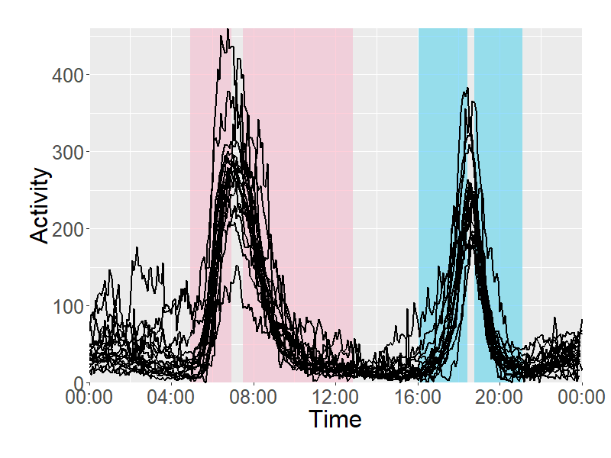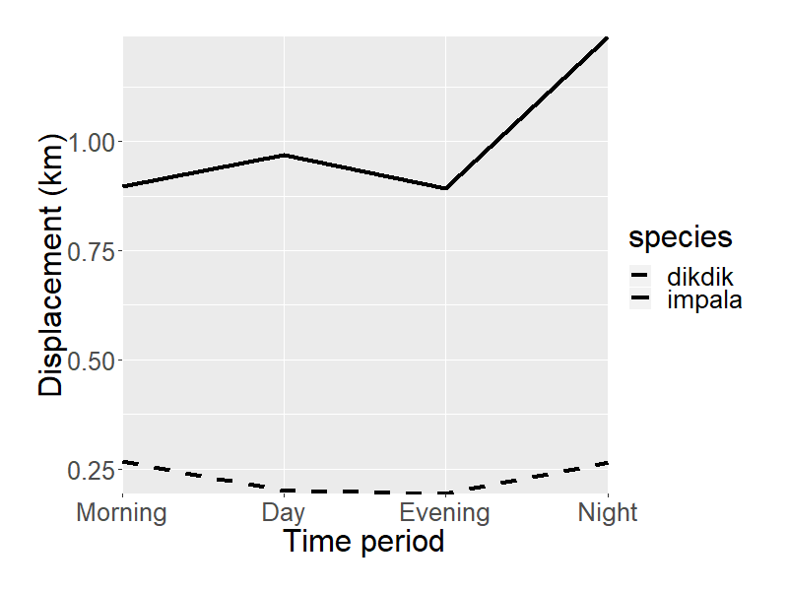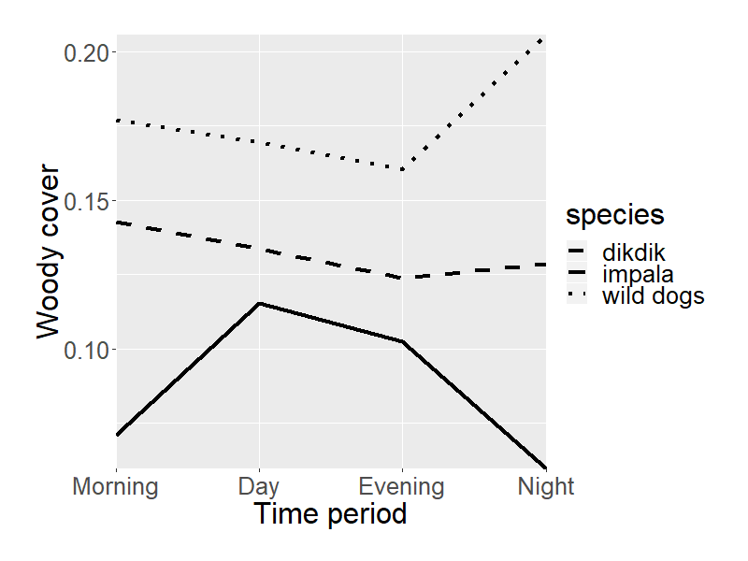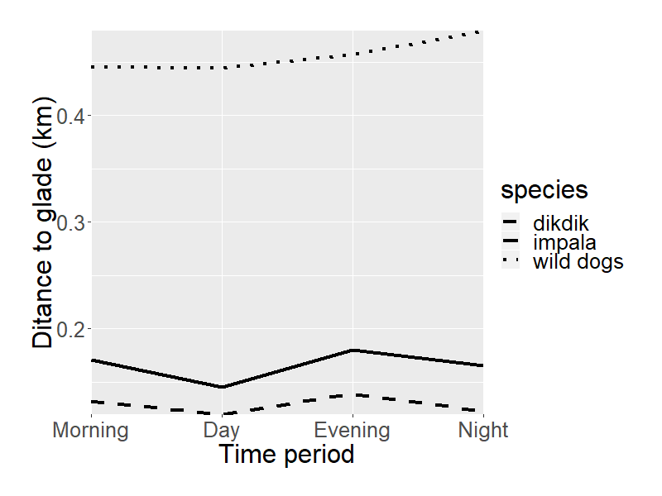

**A**

**B**

**C**

**D**

**Table 1** Hypothesised behavioural changes which might influence African wild dog predation on impala and dikdiks. Shading indicates predictions which were upheld by our statistical models.

|  |  |  |  |  |  |
| --- | --- | --- | --- | --- | --- |
| **Scenario** | **Explanation** | **Predicted behaviour change at high ambient temperature** | | | **Predicted change in relative predation risk** |
| *wild dog (23kg)* | *impala (40kg)* | *dikdik (5kg)* |
| Scenario 1: Foraging during daylight | Reduced foraging in daylight when temperatures are highest, especially in wild dogs as hunting generates more heat than browsing | reduced foraging during daylight  upheld: yes | unchanged foraging during daylight  not tested | unchanged foraging during daylight  not tested | dikdik>impala  dikdiks live at higher densities so are predicted to be selected by a predator with limited time3  upheld: yes |
| Scenario 2: Foraging at night | Wild dogs increase activity at night, because daylight foraging is constrained and prey distribution is more predictable at night | increased foraging at night  upheld: yes | unchanged foraging at night  not tested | unchanged foraging at night  not tested | impala>dikdik:  at night, impala are predictably located in glades4, which wild dogs can target  upheld: no |
| increased use of glades where impala are predictably located    upheld: no |
| Scenario 3: Selection for shaded habitat | All species predicted to select more shaded habitat at high temperatures. | increased preference for dense habitat  upheld: no | increased preference for dense habitat    upheld: yes | increased preference for dense habitat  upheld: no | impala>dikdik:  impala predation risk is higher in denser habitat1  upheld: no |
| Scenario 4: Chase distance | All species overheat when running, but largest-bodied species overheat first | intermediate reduction in running speed  not tested | greatest reduction in running speed  not tested | smallest reduction in running speed  not tested | impala>dikdik:  impala are larger and hence predicted to be more affected by overheating2  upheld: no |

1(Ford *et al.* 2014);2(Creel *et al.* 2016);3(Lucas 1983);4(Augustine 2004).

|  |  |  |  |  |
| --- | --- | --- | --- | --- |
| **Table 2** Start and stop times of bouts allocated to each time period within the analysis. | | | | |
| **Type of Bout** | **Earliest start time** | **Latest start time** | **Earliest stop time** | **Latest stop time** |
| Morning | 04:55:39 | 06:56:04 | 07:30:41 | 12:51:33 |
| Midday | 06:56:05 | 16:01:54 | 12:51:34 | 18:47:02 |
| Evening | 16:01:55 | 18:26:52 | 18:47:03 | 21:06:56 |
| Night | 18:26:53 | 04:55:38 | 21:06:57 | 07:30:40 |

**Table 3** Variables associated with the duration of **African wild dog hunting periods** during daylight, and the occurrence of night-time hunts. The table presents estimated effects of independent variables included in the top model sets (ΔAICc < 5) for the duration (in minutes) of hunting periods in the morning and evening, and the occurrence (or not) of hunts at night. The relative importance of each variable is shown along with the number of models in the top model set in which it was included (n). Bold highlighting indicates estimates for which the 95% confidence interval excluded zero.

|  |  |  |  |  |  |  |  |  |  |  |
| --- | --- | --- | --- | --- | --- | --- | --- | --- | --- | --- |
| **Outcome variable** | **Independent variable** | **Estimate** | | | **Lower**  **95% CI** | | **Upper**  **95% CI** | | | **Variable**  **Importance (n)** |
| Morning hunt duration (minutes) | Intercept | | | 220.06 | 198.78 | | 241.33 | | | — (4) |
| Denning (Yes) | | | -57.48 | -137.38 | | 22.41 | | | 1.00 (4) |
| **Temperature (°C)** | | | **-1.33** | **-2.007** | | **-0.66** | | | **0.88 (3)** |
| Moonlight night before | | | 0.054 | -0.24 | | 0.35 | | | 0.68 (2) |
| Rainfall (mm) | | | -2.97 | -6.31 | | 0.36 | | | 0.60 (1) |
| Rainfall:Temperature | | | 0.13 | 0.004 | | 0.25 | | | 0.60 (1) |
| **Denning:Temperature** | | | **5.015** | **2.83** | | **7.19** | | | **0.58 (1)** |
| Evening hunt duration (minutes) | Intercept | | | 226.49 | 213.95 | | 239.04 | | | — (2) |
| **Temperature (°C)** | | | **-3.01** | **-3.45** | | **-2.57** | | | **1.00 (2)** |
| **Moonlight** | | | **-1.84** | **-2.063** | | **-1.62** | | | **1.00 (2)** |
| Moonrise | | | -0.006 | -0.12 | | 0.11 | | | 1.00 (2) |
| Denning (Yes) | | | 7.43 | -18.14 | | 33.003 | | | 1.00 (2) |
| Rainfall (mm) | | | -0.14 | -2.30 | | 2.16 | | | 0.20 (1) |
| Rainfall:Temperature | | | 0.013 | -0.071 | | 0.098 | | | 0.20 (1) |
| Denning:Temperature | | | 2.04 | 0.50 | | 3.58 | | | 0.15 (1) |
| Night-time hunt occurrence | Intercept | | -0.41 | | | -0.52 | | -0.30 | — (2) | | |
| **Temperature** | | **0.019** | | | **0.016** | | **0.023** | **1.00 (2)** | | |
| **Moonlight** | | **0.031** | | | **0.028** | | **0.033** | **1.00 (2)** | | |
| Denning | | -0.069 | | | -0.094 | | -0.044 | 0.52 (1) | | |

**Table 4** Variables associated with **selection of woody cover** by three species. The table presents estimated effects of independent variables included in the top model sets (ΔAICc < 5). The relative importance of each variable is shown along with the number of models in the top model set in which it was included (n). Bold highlighting indicates estimates for which the 95% confidence interval excluded zero.

|  |  |  |  |  |  |
| --- | --- | --- | --- | --- | --- |
| **Outcome variable** | **Independent variable** | **Estimate** | **Lower**  **95% CI** | **Upper**  **95% CI** | **Variable**  **importance (n)** |
| impala - morning | Intercept | 0.048 | 0.03 | 0.06 | * (1) |
| **Temperature** | **0.002** | **0.001** | **0.002** | **0.98 (1)** |
| impala - midday | Intercept | 0.076 | 0.06 | 0.09 | * (1) |
| **Temperature** | **0.001** | **0.001** | **0.002** | **1.00 (1)** |
| impala - evening | Intercept | 0.091 | 0.09 | 0.1 | * (2) |
| Season (Wet) | -0.002 | -0.004 | -0.0006 | 0.73 (1) |
| Temperature | 0.0005 | 0.0001 | 0.0008 | 0.2 (1) |
| impala - night | Intercept | 0.057 | 0.05 | 0.06 | * (1) |
| Rainfall | 0.00024 | -0.0001 | 0.0006 | 0.86 (1) |
| dikdik - crepuscular | Intercept | 0.12 | 0.1 | 0.2 | (2) |
| Season (Wet) | 0.0055 | -0.0004 | 0.01 | 0.78 (1) |
| Temperature | -0.0008 | -0.001 | 0.000003 | 0.11 (1) |
| dikdik - midday | Intercept | 0.12 | 0.1 | 0.2 | (4) |
| Season (Wet) | -0.0002 | -0.006 | 0.006 | 0.59 (1) |
| Moonlight | 0.0009 | 0.0003 | 0.001 | 0.21 (1) |
| Rain (mm) | 0.0005 | 0.0002 | 0.0009 | 0.10 (1) |
| Temperature | 0.0004 | -0.0004 | 0.001 | 0.09 (1) |
| dikdik - night | Intercept | 0.13 | 0.1 | 0.2 | (2) |
| **Moonlight** | **-0.022** | **-0.03** | **-0.01** | **0.71 (1)** |
| **Season (Wet)** | **0.023** | **0.02** | **0.03** | **0.32 (1)** |
| wild dog - crepuscular | Intercept | 0.16 | 0.1 | 0.2 | - (1) |
| **denning vs not** | **-0.036** | **-0.05** | **-0.02** | **1.00 (1)** |
| wild dog - night | Intercept | 0.15 | 0.1 | 0.2 | - (1) |
| **denning vs not** | **-0.12** | **-0.14** | **-0.09** | **1.00 (1)** |

**Table 5** Variables associated with **use of glades** by three species. The table presents estimated effects of independent variables included in the top model sets (ΔAICc < 5. The relative importance of each variable is shown along with the number of models in the top model set in which it was included (n). Bold highlighting indicates estimates for which the 95% confidence interval excluded zero.

|  |  |  |  |  |  |  |
| --- | --- | --- | --- | --- | --- | --- |
| **Outcome variable** | **Independent variable** | **Estimate** | | **Lower**  **95% CI** | **Upper**  **95% CI** | **Variable**  **importance (n)** |
| impala in glade – 24h | Intercept | | 0.039 | 0.022 | 0.055 | * (1) |
| **morning *vs* midday** | | **0.06** | **0.06** | **0.07** | **1.00 (1)** |
| **evening *vs* midday** | | **-0.009** | **-0.01** | **-0.005** | **1.00 (1)** |
| **night *vs* midday** | | **0.19** | **0.18** | **0.20** | **1.00 (1)** |
| impala in glade - night | Intercept | | 0.26 | -0.007 | 0.03 | * (1) |
| **Moonlight** | | **-0.072** | **-0.08** | **-0.06** | **1.00 (1)** |
| **Rainfall** | | **-0.0025** | **-0.003** | **-0.002** | **0.94 (1)** |
| **Temperature** | | **0.006** | **0.004** | **0.008** | **0.06 (1)** |
| dikdiks in glade – 24h | Intercept | | 0.030 | 0.02 | 0.04 | * — (1) |
| wet *vs* dry phase | | -0.015 | -0.02 | -0.006 | 0.96 (1) |
| dikdiks in glade - night | Intercept | | 0.012 | -0.007 | 0.03 | * (1) |
| **Moonlight** | | **0.042** | **0.03** | **0.05** | **0.97(1)** |
| wild dog distance to glade – 24h | Intercept | | 0.58 | 0.5 | 0.6 | — (1) |
| **Pack size** | | **-0.012** | **-0.01** | **-0.02** | **0.90 (1)** |
| wild dog distance to glade – night | Intercept | | 0.55 | 0.4 | 0.7 | (5) |
| **Pack Size** | | **-0.020** | **-0.03** | **-0.01** | **0.67(2)** |
| Moonlight | | 0.064 | 0.03 | 0.1 | 0.27 (2) |
| denning *vs* not | | -0.051 | -0.004 | -0.1 | 0.11 (1) |
| wet *vs* dry phase | | -0.039 | -0.08 | -0.001 | 0.08 (1) |

**Table 6** Variables associated with **African wild dog consumption of impala**. The table presents estimated effects of independent variables included in the top model sets (ΔAICc<5). The relative importance of each variable is shown along with the number of models in the top model set in which it was included (n). Bold highlighting indicates estimates for which the 95% confidence interval excluded zero.

|  |  |  |  |  |
| --- | --- | --- | --- | --- |
| **Independent variable** | **Estimate** | **Lower 95% CI** | **Upper 95% CI** | **Variable importance (n)** |
| Intercept | 0.74 | 0.5 | 1.01 | — (2) |
| **Temperature in previous 7 days** | **-0.021** | **-0.03** | **-0.01** | **1.00 (1)** |
| Community vs private land | -0.63 | -0.1 | -0.02 | 0.10 (1) |

**Impacts of temperature on predator-prey interactions in an African savanna**

D. Rabaiotti1,2, Adam T. Ford3, Ben Chapple2, Sophie Morrill2,

and Rosie Woodroffe1

***Supporting Information***

**Figure S1** Frequency distribution of (A) start times and (B) stop times of African wild dog hunting bouts, identified using collar-mounted accelerometers.

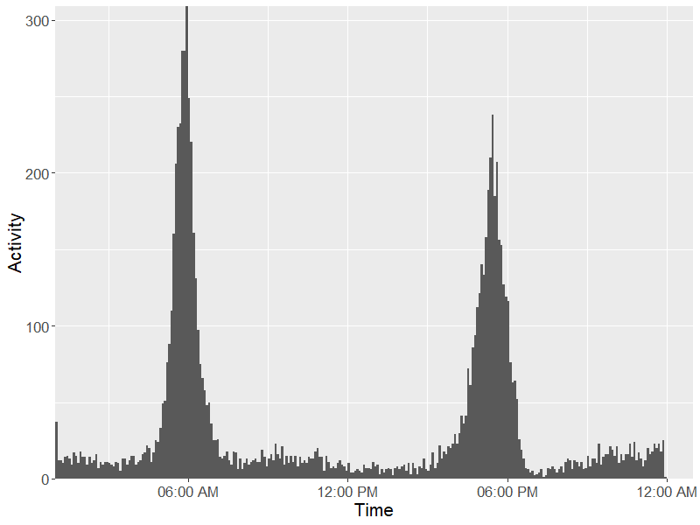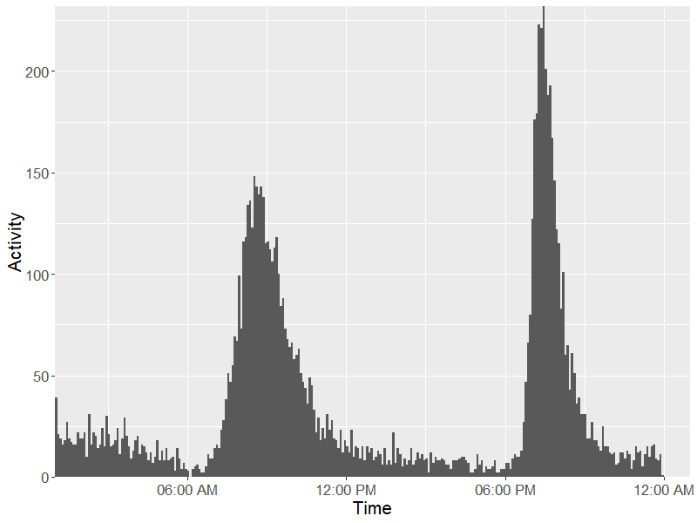

**A**

**B**

**Time**

**Table S1** Variables associated with the characteristics of African wild dog hunting periods in the **morning**. The table presents estimated effects of independent variables included in the top model sets (ΔAICc < 5) for each outcome variable. The relative importance of each variable is shown along with the number of models in the top model set in which it was included (n). Bold highlighting indicates estimates for which the 95% confidence interval excluded zero.

|  |  |  |  |  |  |  |  |
| --- | --- | --- | --- | --- | --- | --- | --- |
| **Outcome variable** | **Independent variable** | | **Estimate** | **Lower**  **95% CI** | **Upper**  **95% CI** | **Variable**  **importance (n)** | |
| Occurrence | Intercept | | 0.80 | 0.77 | 0.83 | | — (1) |
| **Moonlight before** | | **-0.0097** | **-0.011** | **-0.0079** | | **1.00 (1)** |
| Duration  (minutes) | Intercept | | 220.06 | 198.78 | 241.33 | | — (4) |
| Denning (Yes) | | -57.48 | -137.38 | 22.41 | | 1.00 (4) |
| **Temperature (°C)** | | **-1.33** | **-2.007** | **-0.66** | | **0.88 (3)** |
| Moonlight before | | 0.054 | -0.24 | 0.35 | | 0.68 (2) |
| Rainfall (mm) | | -2.97 | -6.31 | 0.36 | | 0.60 (1) |
| Rainfall:Temperature | | 0.13 | 0.004 | 0.25 | | 0.60 (1) |
| **Denning:Temperature** | | **5.015** | **2.83** | **7.19** | | **0.58 (1)** |
| Intensity | Intercept | | 51.43 | 46.78 | 56.076 | | **— (3)** |
| **Denning (Yes)** | | **1.56** | **0.14** | **0.16** | | **0.89 (2)** |
| **Temperature (°C)** | | **-0.26** | **-0.38** | **-0.14** | | **0.57 (2)** |
| Start time | Intercept | 06:31:41 | | 06:24:07 | 06:39:14 | | * (1) |
| **Denning (Yes)** | **-00:07:46** | | **-00:06:14** | **-00:09:18** | | **1(1)** |
| **Temperature (°C)** | **-00:01:15** | | **-00:01:01** | **-00:01:29** | | **0.99(1)** |
| Stop time | Intercept | | 09:54:52 | 09:20:48 | 10:28:56 | | * (3) |
| **Temperature (°C)** | **-00:02:28** | | **-00:01:53** | **-00:03:03** | | **0.72(2)** |
| **Denning (Yes)** | **00:13:25** | | **00:09:37** | **00:17:14** | | **0.57(2)** |

**Table S2** Variables associated with the characteristics of African wild dog hunting periods in the **evening**. The table presents estimated effects of independent variables included in the top model sets (ΔAICc < 5) for each outcome variable. The relative importance of each variable is shown along with the number of models in the top model set in which it was included (n). Bold highlighting indicates estimates for which the 95% confidence interval excluded zero.

|  |  |  |  |  |  |  |  |
| --- | --- | --- | --- | --- | --- | --- | --- |
| **Outcome variable** | **Independent variable** | | **Estimate** | **Lower 95% CI** | **Upper 95% CI** | **Variable**  **importance (n)** | |
| Occurrence | Intercept | | 1.21 | 1.08 | 1.35 | | — (2) |
| **Moonlight** | | **-0.010** | **-0.012** | **-0.008** | | **1.00 (2)** |
| **Temperature (°C)** | | **-0.017** | **-0.021** | **-0.013** | | **0.97 (2)** |
|  | Denning (Yes) | | 0.042 | 0.016 | 0.069 | | 0.08 (1) |
| Duration  (minutes) | Intercept | | 226.49 | 213.95 | 239.04 | | — (2) |
| **Temperature (°C)** | | **-3.01** | **-3.45** | **-2.57** | | **1.00 (2)** |
| **Moonlight** | | **-1.84** | **-2.06** | **-1.62** | | **1.00 (2)** |
| Moonrise | | -0.006 | -0.12 | 0.11 | | 1.00 (2) |
| Denning (Yes) | | 7.43 | -18.14 | 33.00 | | 1.00 (2) |
| Rainfall (mm) | | -0.14 | -2.30 | 2.16 | | 0.20 (1) |
| Rainfall:Temperature | | 0.013 | -0.071 | 0.098 | | 0.20 (1) |
| Denning:Temperature | | 2.04 | 0.50 | 3.58 | | 0.15 (1) |
| Intensity | Intercept | | 62.98 | 46.78 | 56.08 | | — (4) |
| **Temperature (°C)** | | **-0.83** | **-0.96** | **-0.70** | | **1.00 (4)** |
| Denning (Yes) | | 7.50 | 2.55 | 12.45 | | 1.00 (4) |
| **Moonlight** | | **-0.21** | **-0.27** | **-0.15** | | **0.45 (3)** |
| Moonrise | | -0.006 | -0.038 | 0.027 | | 0.45 (3) |
| Rainfall (mm) | | -1.14 | -2.04 | -0.78 | | 0.14 (1) |
| Rainfall:Temperature | | 0.058 | 0.034 | 0.082 | | 0.14 (1) |
| Denning:Temperature | | -0.58 | -1.01 | -0.13 | | 0.07 (1) |
| Start time | Intercept | 15:43:55 | | 15:34:49 | 15:53:01 | | * (2) |
| **Temperature (°C)** | **00:03:30** | | **00:03:11** | **00:03:49** | | **1.00 (2)** |
| **Denning (Yes)** | **-00:10:49** | | **-00:08:52** | **-00:09:18** | | **1.00 (2)** |
| **Moonlight** | **00:01:01** | | **00:00:52** | **00:01:10** | | **0.90 (1)** |
| Moonrise | -00:00:01 | | -00:00:05 | 00:00:05 | | 0.90 (1) |
| Stop time | Intercept | 19:42:14 | | 19:38:50 | 19:45:39 | | * (2) |
| **Denning (Yes)** | **00:13:25** | | **00:09:37** | **00:17:14** | | **0.55(1)** |
| **Moonlight** | **00:00:52** | | **00:00:43** | **00:01:02** | | **0.44(1)** |
| Moonrise | 00:00:01 | | -00:00:04 | 00:00:06 | | 0.44(1) |

**Table S3** Variables associated with the characteristics of African wild dog hunting periods **at night**. The table presents estimated effects of independent variables included in the top model sets (ΔAICc < 5) for each outcome variable. The relative importance of each variable is shown along with the number of models in the top model set in which it was included (n). Bold highlighting indicates estimates for which the 95% confidence interval excluded zero.

|  |  |  |  |  |  |  |  |
| --- | --- | --- | --- | --- | --- | --- | --- |
| **Outcome variable** | **Independent variable** | | **Estimate** | **Lower 95% CI** | **Upper 95% CI** | **Variable importance (n)** | |
| Occurrence | Intercept | | -0.41 | -0.52 | -0.30 | | — (2) |
| **Temperature** | | **0.019** | **0.016** | **0.023** | | **1.00 (2)** |
| **Moonlight** | | **0.031** | **0.028** | **0.033** | | **1.00 (2)** |
| Denning | | -0.069 | -0.094 | -0.044 | | 0.52 (1) |
| Duration  (minutes) | Intercept | | 80.69 | 47.72 | 113.66 | | — (4) |
| **Moonlight** | | **5.59** | **5.00** | **6.18** | | **1.00 (4)** |
| **Moonrise** | | **0.83** | **0.42** | **1.25** | | **1.00 (4)** |
| Denning (Yes) | | 102.12 | -52.87 | 257.11 | | 0.94 (4) |
| Temperature (°C) | | 0.71 | -0.55 | 1.97 | | 0.79 (3) |
| Rainfall (mm) | | -0.54 | -7.66 | 6.57 | | 0.53 (2) |
| Rainfall:Temperature | | 0.004 | -0.27 | 0.27 | | 0.51 (1) |
| Denning:Temperature | | -7.42 | -13.76 | -1.10 | | 0.47 (2) |
| Intensity | Intercept | | 28.51 | 20.67 | 36.36 | | — (4) |
| **Moonlight** | | **0.86** | **0.75** | **0.98** | | **1.00 (4)** |
| Moonrise | | -0.011 | -0.10 | -0.072 | | 1.00 (4) |
| Denning (Yes) | | 1.82 | -3.17 | 6.84 | | 0.75 (2) |
| **Temperature (°C)** | | **0.42** | **0.18** | **0.66** | | **0.52 (2)** |
| Start time | Intercept | 15:52:55 | | 09:34:32 | 22:11:08 | | * (2) |
| **Moonrise** | **00:24:22** | | **00:20:30** | **00:24:22** | | **1.00 (2)** |
| Moonlight | -00:05:15 | | -00:10:38 | 00:00:08 | | 1.00 (2) |
| **Temperature (°C)** | **-00:29:38** | | **-00:18:57** | **-00:40:20** | | **0.22 (1)** |
| Stop time | Intercept | 09:14:33 | | 06:28:31 | 12:00:35 | | * (3) |
| **Moonlight** | **-00:24:17** | | **-00:20:20** | **-00:28:14** | | **1.00 (3)** |
| Moonrise | 00:03:22 | | 00:00:31 | 00:06:12 | | 1.00 (3) |
| **Denning (Yes)** | **02:22:25** | | **01:11:11** | **03:33:39** | | **0.25 (1)** |
|  | **Temperature** | **00:19:04** | | **00:11:10** | **00:26:57** | | **0.08 (1)** |